5/27/2026
Shekhar Podutwar
27/5/2026
Jenkins Pipeline Integration with Git Repository on AWS EC2
Configure AWS EC2

Contents

Document Version History……………………………….…………………………………………….1
Introduction…………………….…………………………………………………………………………….2
Objectives…………………….………………………..….………………………………………………….3
Tools & Technologies Used…………………………………………………………………………….4
Architecture Overview ………………………………………………………………………………….5
Step-by-Step Implementation …………………………………..………………………………….6
Conclusion…………………………………………………………………………………………………….7

Document Version History

Version Number | Date Modified | Author | Changes
Draft | 27/5/2026 | Shekhar | Draft Version

Introduction
This project focuses on setting up Jenkins on an AWS EC2 instance and integrating it with a Git repository to implement Continuous Integration and Continuous Deployment (CI/CD) automation. The project included creating an EC2 instance in Amazon Web Services, connecting the server using PuTTY, installing Java and Jenkins, configuring Jenkins services, opening required ports, and creating Jenkins Pipeline jobs.
Additionally, the Jenkins pipeline was configured to clone source code from a Git repository automatically, enabling automated build and deployment workflows. This setup improved deployment speed reduced manual work, and enhanced software delivery efficiency.

Objectives

- Create and configure AWS EC2 instance for Jenkins setup.
- Connect EC2 instance securely using PuTTY and SSH.
- Install Java and Jenkins on Linux server environment.
- Configure Jenkins repository and required dependencies.
- Start and manage Jenkins services successfully.
- Open required ports for Jenkins dashboard access.
- Integrate Git repository with Jenkins Pipeline.
- Automate source code cloning, build, and deployment processes.
- Gain practical experience in CI/CD pipeline automation.
Tools and Technologies
Category | Tools / Technologies
Cloud Platform | Amazon Web Services (AWS)
Compute Service | Amazon EC2
Automation Tool | Jenkins
Version Control | GitHub / Git
Operating System | Linux (Ubuntu / Amazon Linux)
Remote Access Tool | PuTTY / SSH
Dependency Package | Java (OpenJDK)
Repository Configuration | Jenkins Repository & GPG Key
CI/CD Implementation | Jenkins Pipeline
Scripting | Bash Shell Scripting
Networking | Security Groups, Port 8080
Source Code Management | Git Clone Operation

Architecture Overview
Developer Code Commit
↓
GitHub Repository
↓
AWS EC2 Instance
↓
Jenkins Installed on Linux Server
↓
Jenkins Pipeline Trigger
↓
Git Repository Clone
↓
Build & Deployment Process
↓
Automated CI/CD Workflow
Step-by-Step Implementation

Step 1: Login AWS and create an instance
- Select AMI (Ubuntu Server 24.04 LTS (HVM), SSD Volume Type)
- Create a Jenkins key pair
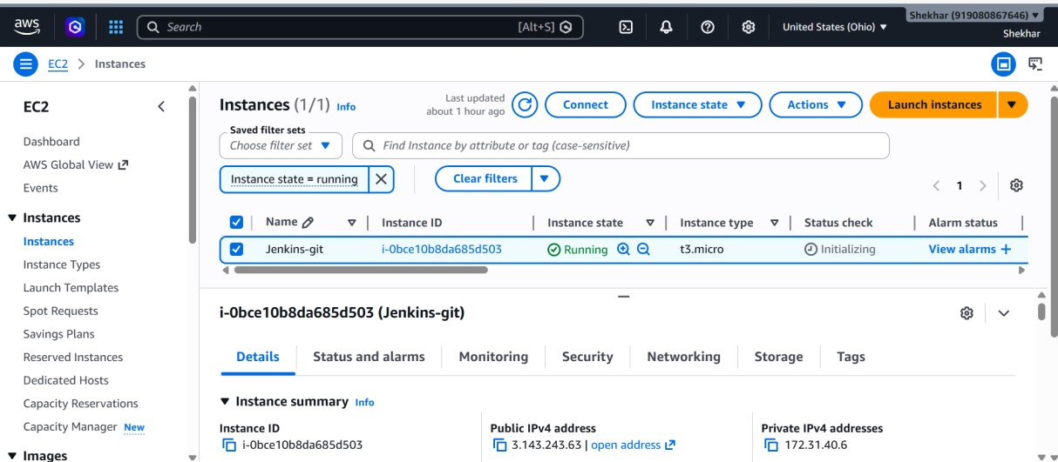
Step 2: Connect putty and run following commands
- ubuntu
- Sudo su -
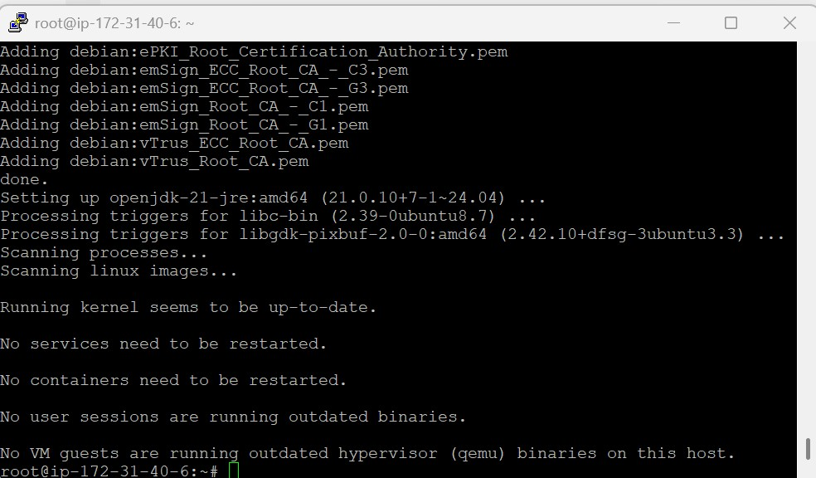
- Update the repository.
(apt update –y)

- Install the Java package.
(apt install fontconfig openjdk-21-jre –y)

- Download the official Jenkins GPG key.
wget -O /etc/apt/keyrings/jenkins-keyring.asc
https://pkg.jenkins.io/debian-stable/jenkins.io-2026.key

- Add the Jenkins repository to the system.
echo "deb [signed-by=/etc/apt/keyrings/jenkins-keyring.asc]" https://pkg.jenkins.io/debian-stable binary/ | sudo tee
/etc/apt/sources.list.d/jenkins.list > /dev/null

- Update the repository again.
(apt update –y)

- Install Jenkins.
(apt install jenkins –y)

- Start the Jenkins service.
(systemctl start jenkins)

- Add the Jenkins user to the sudoers file.
vim /etc/sudoers
jenkins ALL=(ALL) NOPASSWD: ALL

Step 3: Open port no 8080
- Security --> security group --> edit inbound rule --> add rule
- Must be select Any-where-Ipv4
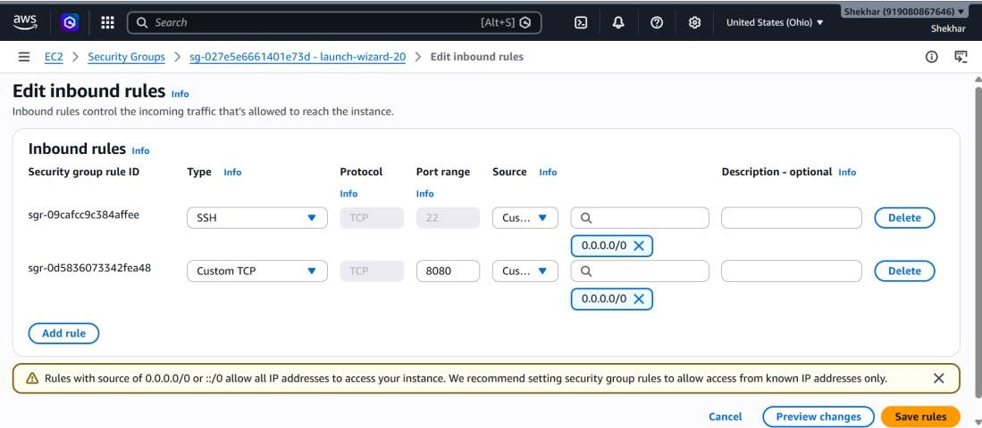
Step 4: To configure Jenkins
- Connect to http:public_ip:8080 from our browser.
- We will be able to access Jenkins through its management interface:
- Default home directory for Jenkins
(/var/lib/jenkins)
- workspace directory of Jenkins. (/var/lib/jenkins/workspace/job1/file1)
- For password
(cat past path)
(cat /var/lib/jenkins/secrets/initialAdminPassword)
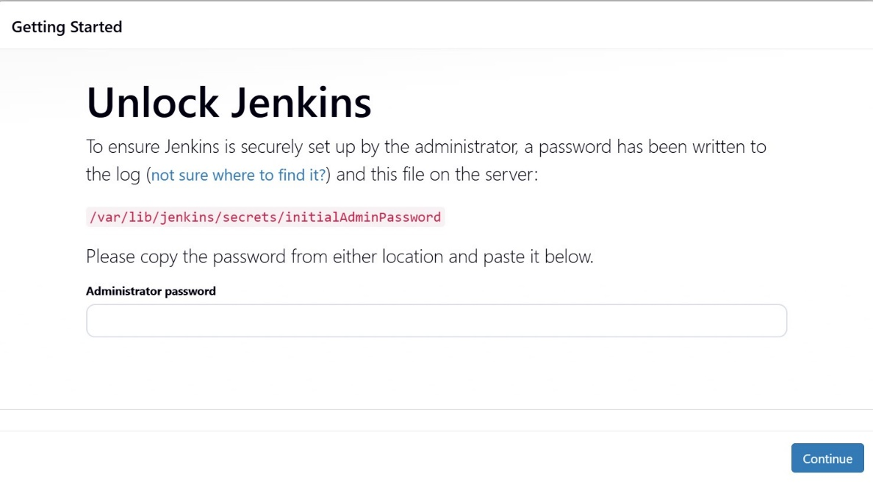
Step 5: Now you can access Jenkins dashboard
- Select installs suggested plugins
- Then setup username and password
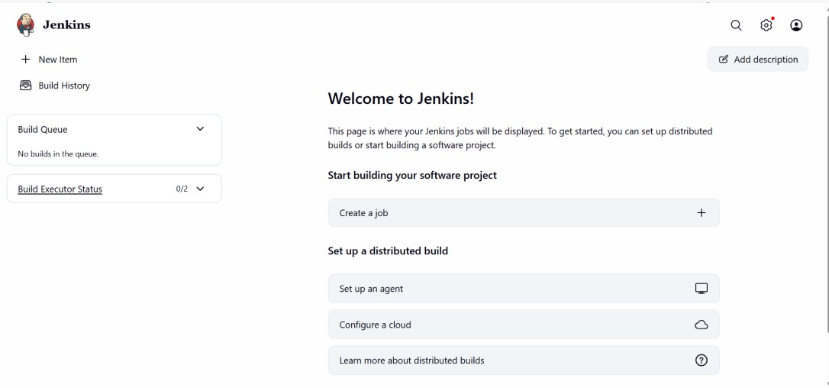
Step 6: Creating another server
- Dev-server and connect putty
- Girt install
- Mkdir /dir1
- Cd /dir1
- Git init
- Touch file1 file2
- Git add file1 file2
- Git commit –m “discription” file1 file2
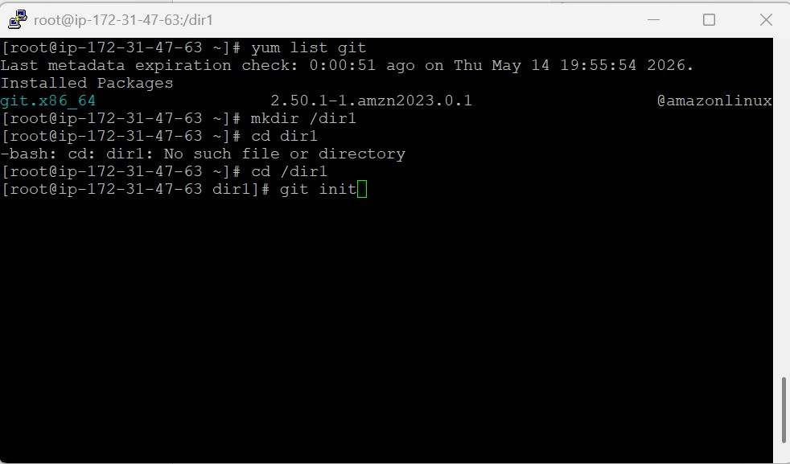
Step 7: Creating GitHub Repo
- Connect with Linux Machin
- git remote add origin URL of your repo - git remote add origin https://github.com/ShekharGit27/jenkins-repo.git
- Git push origin master
- Add username: ShekharGit27
- Token:
Git profile--> setting--> developer setting--> personal access token--
>token classic--> generate new token
Select all check box--> generate token
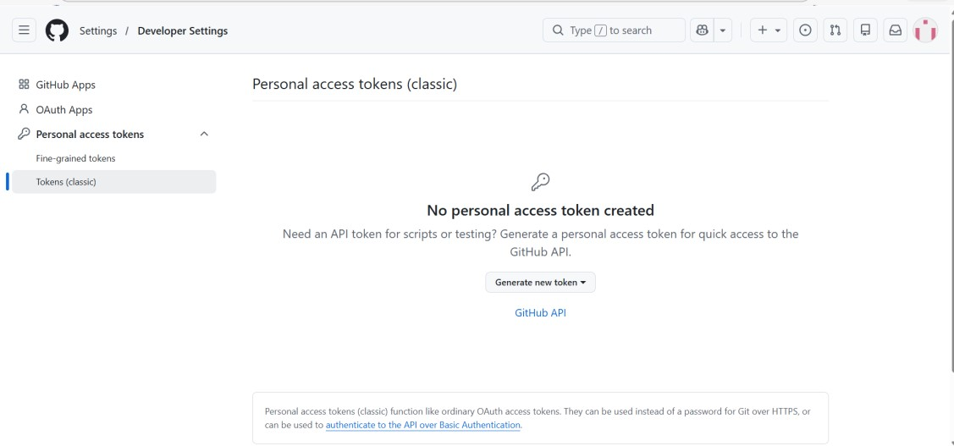
Step 8: Now your repo successfully connected
- Now your file1 and file2 is showing
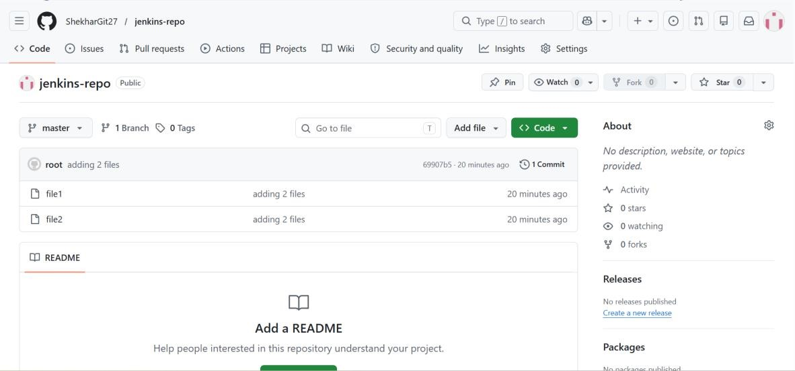
Step 9: Create a job in Jenkins
- Now you can create job in Jenkins
- New item--> job--> freestyle project
- build step--> add build step-->execute shell
- Add commands
- Git clone https://github.com/ShekharGit27/jenkins-repo.git
- Apply and save
- Build job
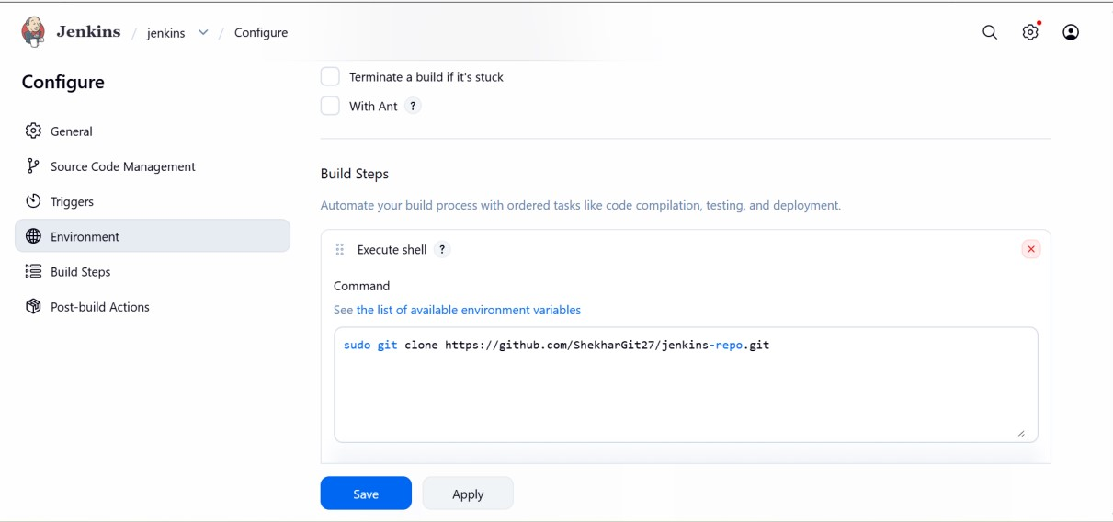
Step 10: default Jenkins directory
- Now you can create job in Jenkins
- Default home directory for Jenkins
(/var/lib/jenkins)
- workspace directory of Jenkins.
(/var/lib/jenkins/workspace/jenkins/jenkins-repo)
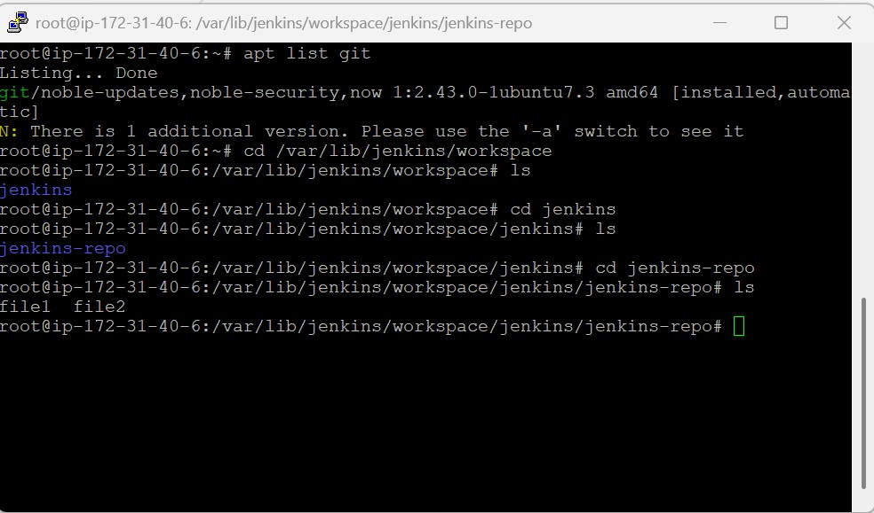
Conclusion
This project successfully demonstrated the setup and integration of Jenkins with AWS EC2 and Git repositories for implementing CI/CD automation. The project included Java installation, Jenkins repository configuration, service management, Jenkins Pipeline creation, and automatic Git repository cloning for build execution. By automating source code integration and deployment workflows, the project improved deployment efficiency, minimized manual intervention, and enhanced software delivery reliability. This project also provided hands-on experience in AWS infrastructure management, Jenkins administration, Git integration, and DevOps automation practices using Amazon Web Services.

